**CHAPTER 1**

**INTRODUCTION**

Tourism has turned out to be an economic booster contributing to the economic development of many countries over the last few decades. People see holidays as a necessity, and not as luxury in the present scenario. Tourism calls for coordination and cooperation between travel agents, tour operators, and tourists. Tourism has a few major elements − destinations, attractions, sites, accommodation, and all ancillary services. Tourism involves the activities of people travelling and staying in a place away from their home environment for leisure, business or other purposes.

Tourism was mainly been traditional in its early form. With the evolution of cultures, economies, and knowledge, tourism took a different form called sustainable tourism with the aspect of well-planned tour, well-studied destination, and conservation of destination. Tourism management system  involves the management of multitude of activities such as studying tour destination, planning the tour, making travel arrangements and providing accommodation. It also involves marketing efforts to attract tourists to travel to particular destinations.

**CHAPTER 2**

**CONCEPT DEFINITION AND SCOPE**

**2.1 Concept Statement**

As the name specifies “TOURISM MANAGEMENT SYSTEM” is a software developed for managing tour booking. Identification of the drawbacks of the existing system leads to the designing of computerized system that will be compatible to the existing system with the system Which is more user friendly and more GUI oriented. We can improve the efficiency of the system, thus overcome the drawbacks of the existing system.

· Less human error

· Strength and strain of manual labour can be reduced

· High security

· Data redundancy can be avoided to some extent

· Easy to handle ·

**2.2 Scope**

Tourism Management System is an integrated software developed for tour operating companies. The main aim of this project is to help the tourism companies to manage their customers, vehicles, and agent. It makes all operation of the tour company easy and accurate. The standalone platform makes tourism management easy by handing agencies requests and providing servers for the customers located at different parts of the various cities. Different modules have been incorporated in this project to handle different parts and sector of the tour management field.

**CHAPTER 3**

**IMPLEMENTATION**

**3.1 Home Page**

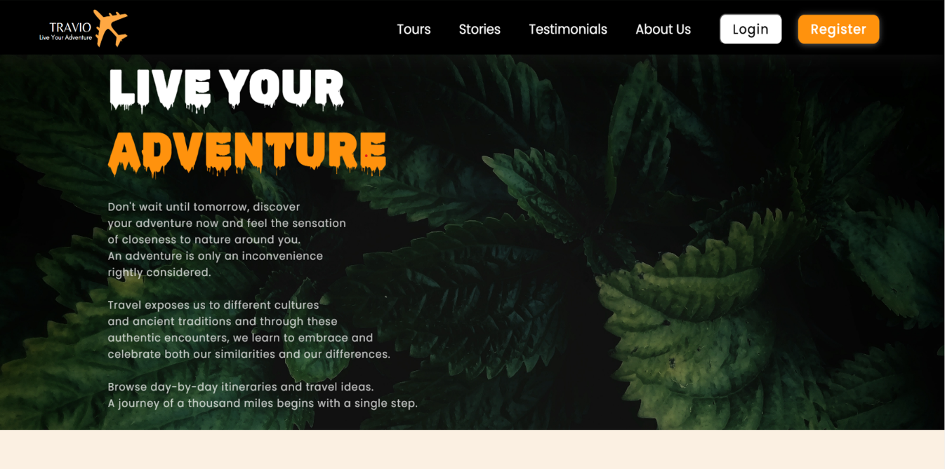

Fig 3.1

**3.2 Tours**

**A] Tours**

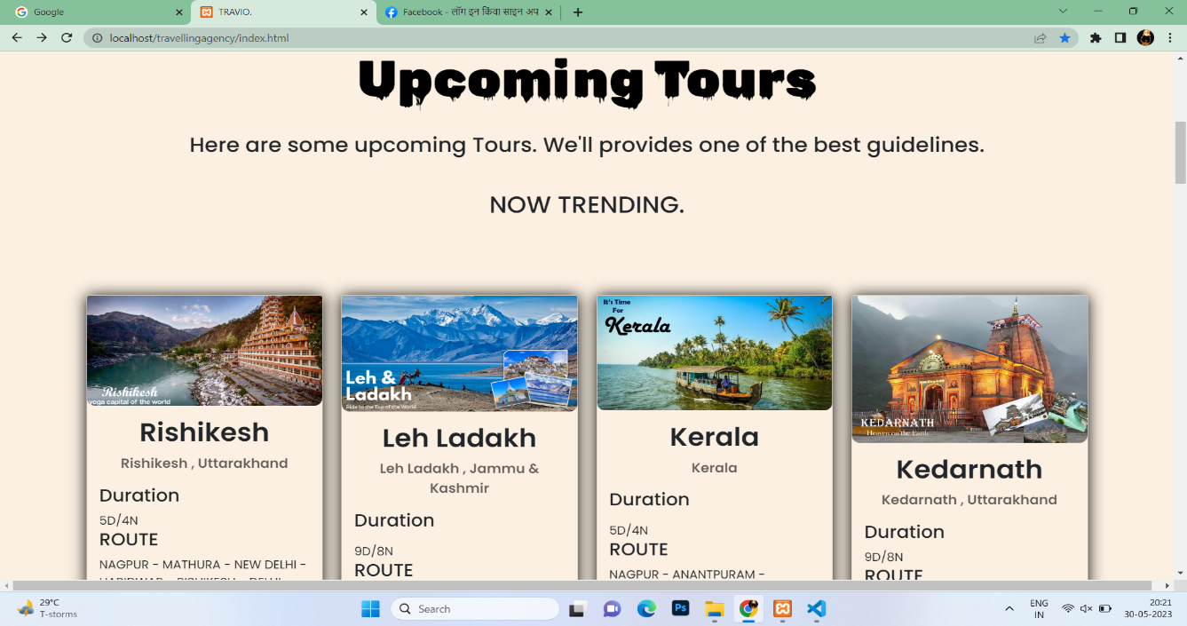

Fig 3.2(1)

B] **Tours**

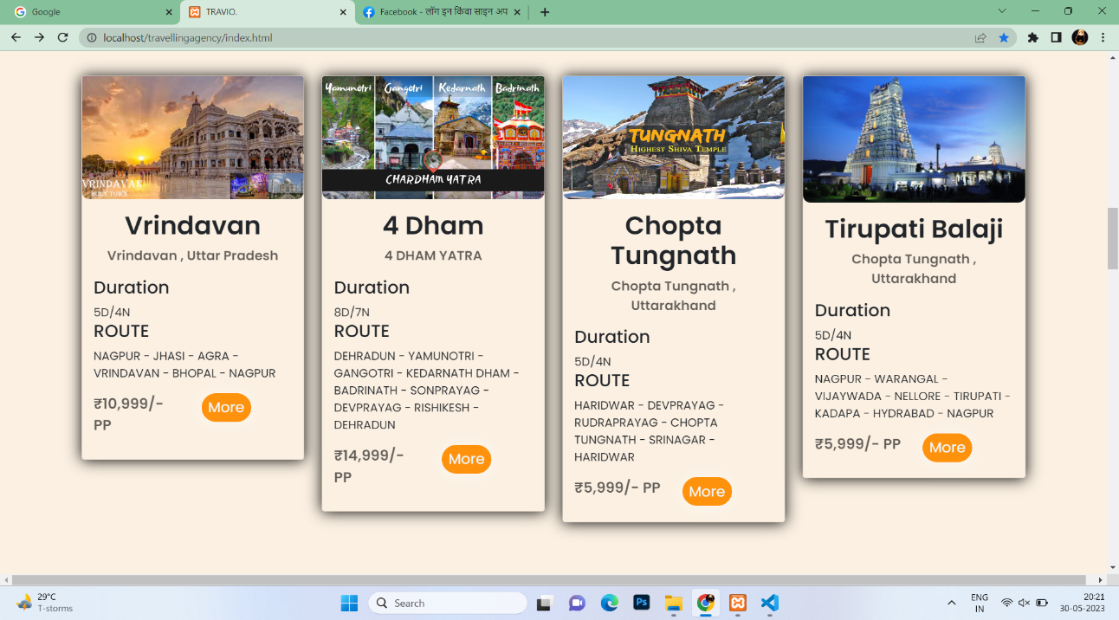

Fig 3.2(2)

**3.3 Stories**

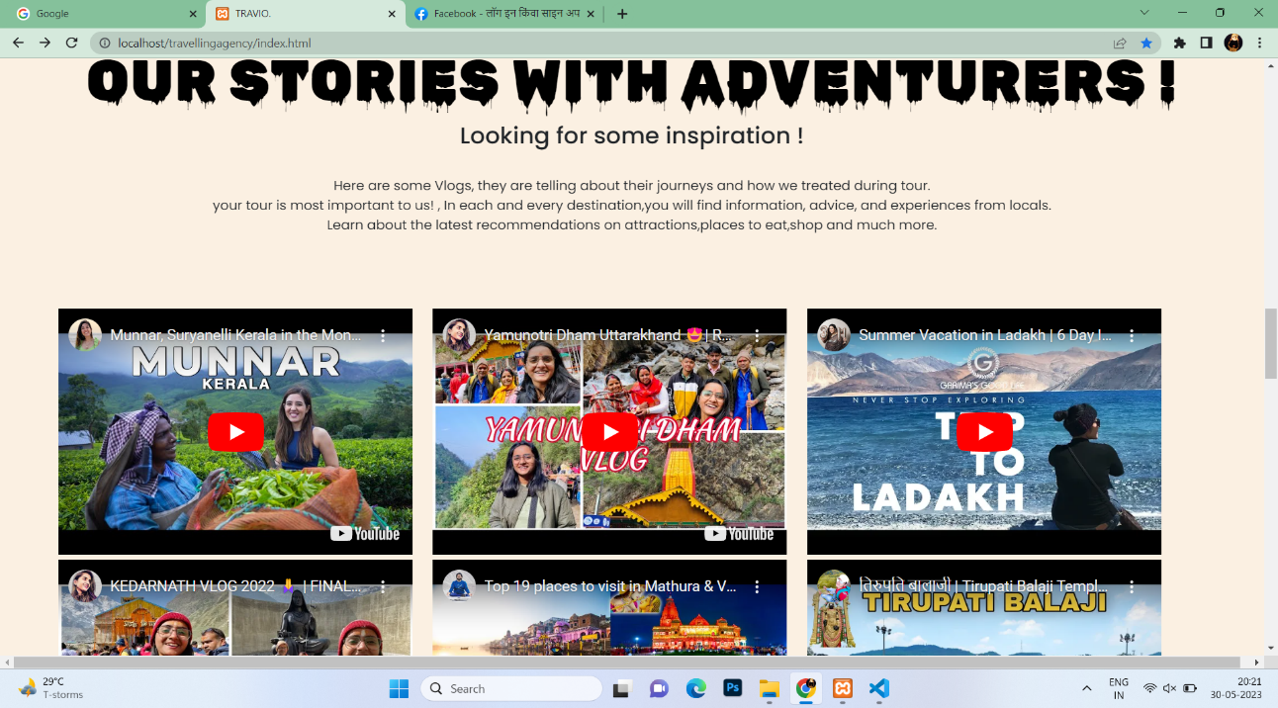

Fig 3.3

**3.4 Testimonials**

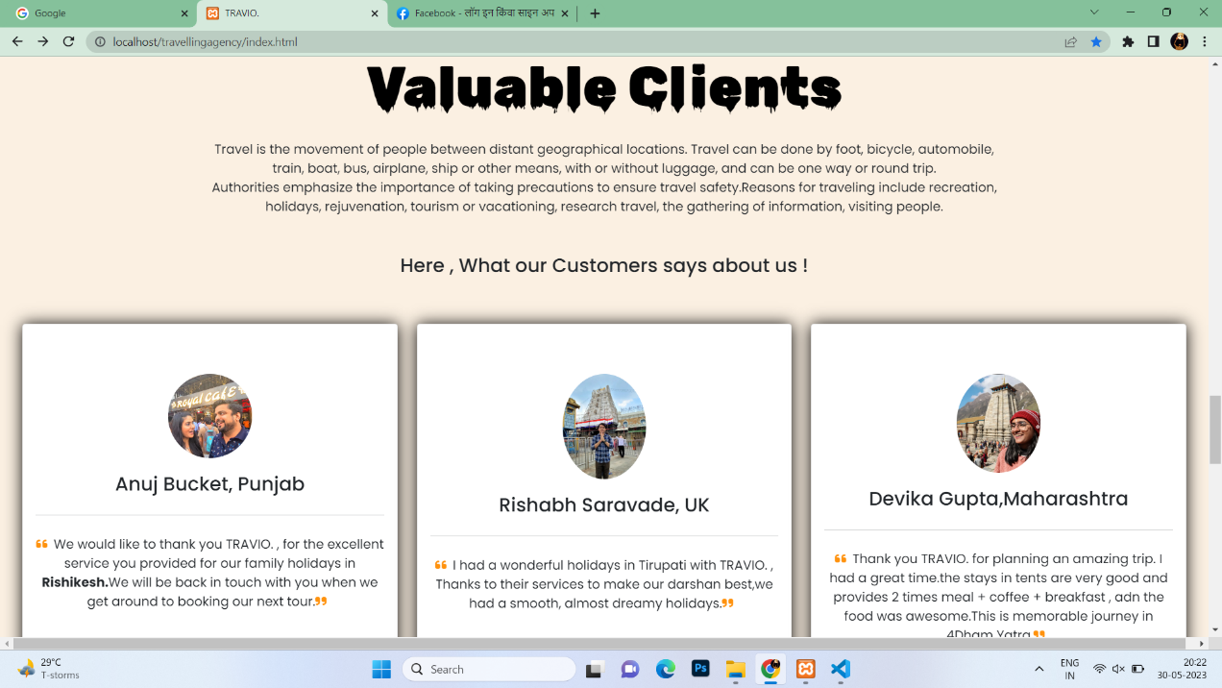

Fig 3.4

**3.5 About Us**

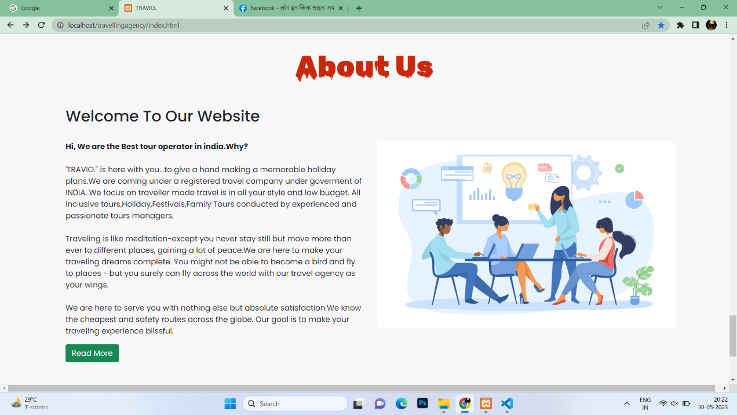

Fig 3.5

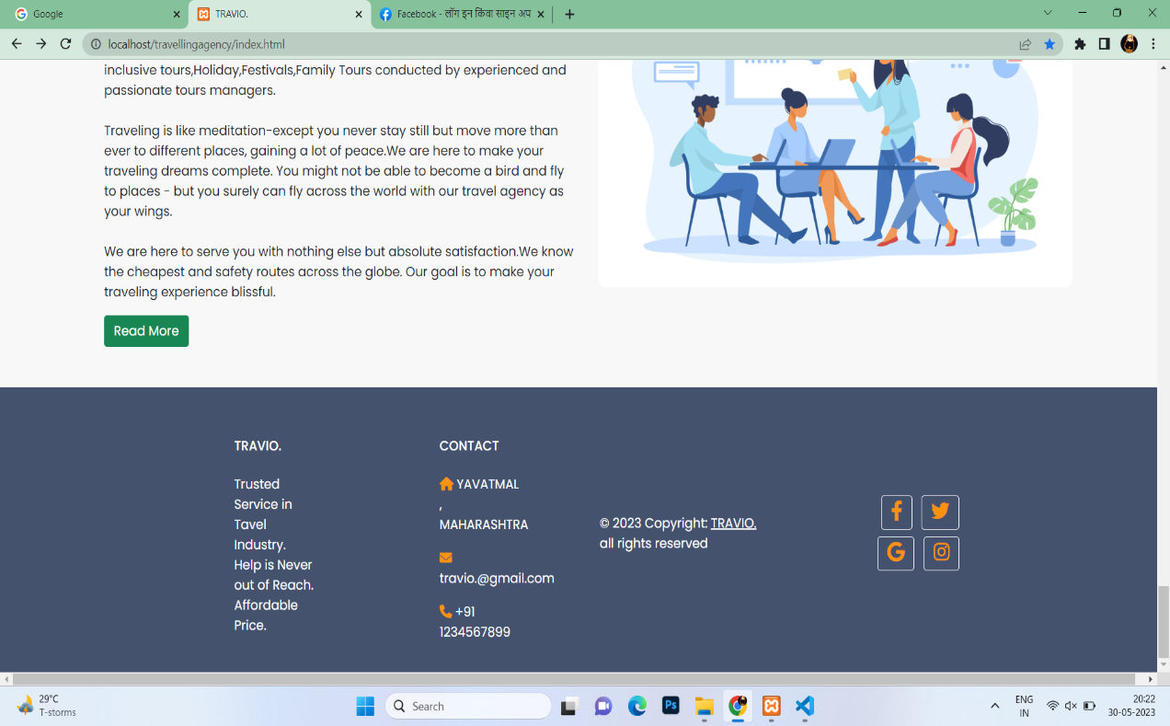

Fig 3.5

**3.6 Login And Registration Page**

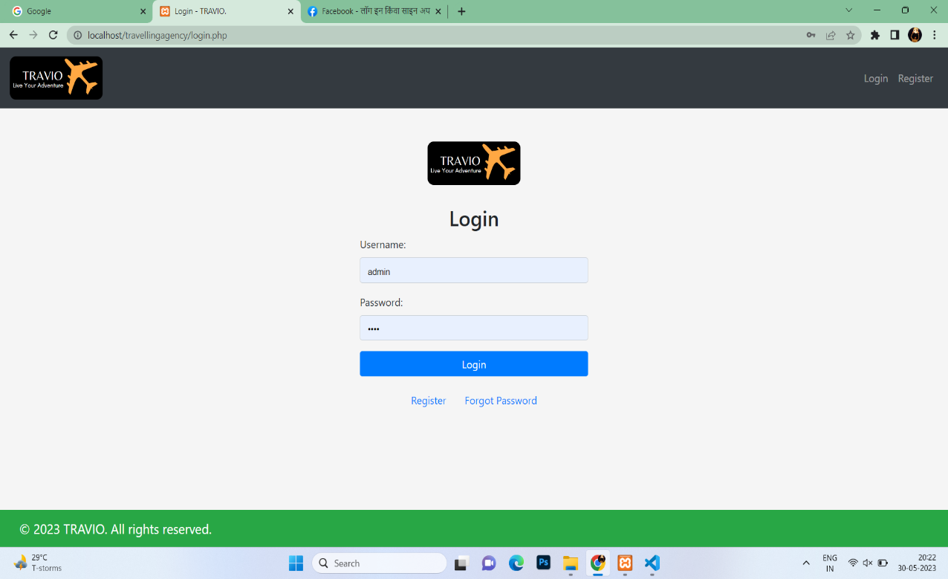

Fig 3.6

**3.7 Travel Webpage**

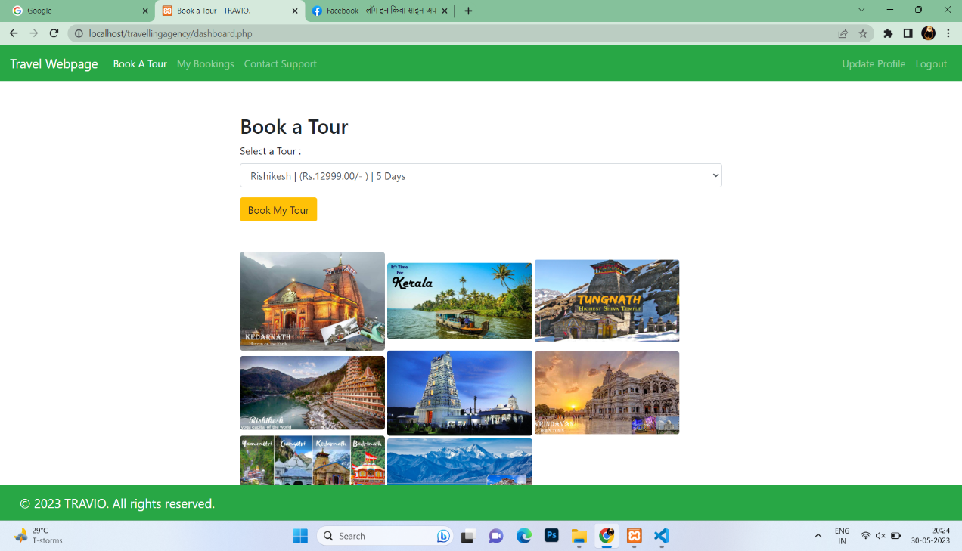

Fig 3.7

**3.8 Admin Page**

**A] Bookings**

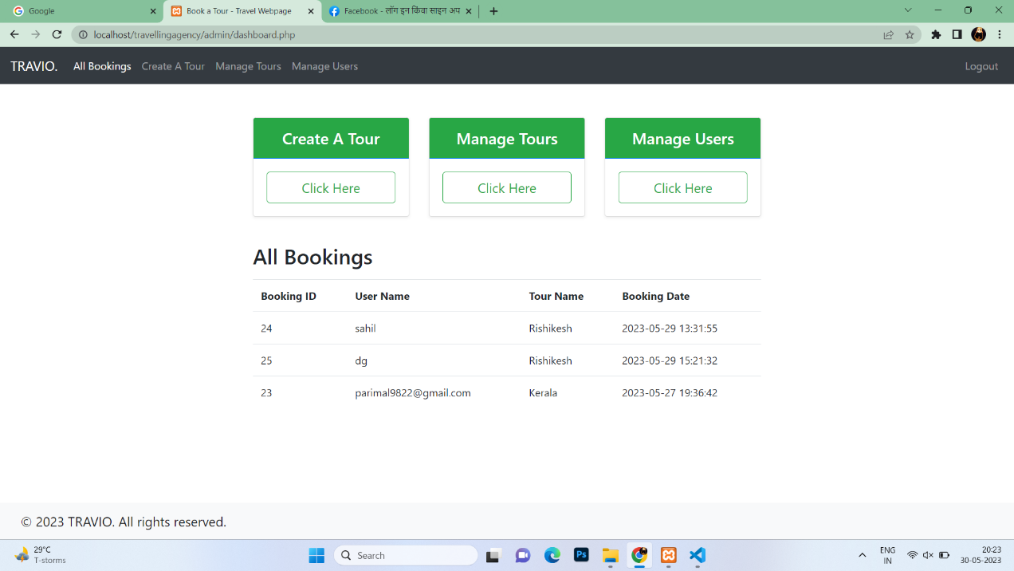

Fig 3.8(1)

**B] Create Tour**

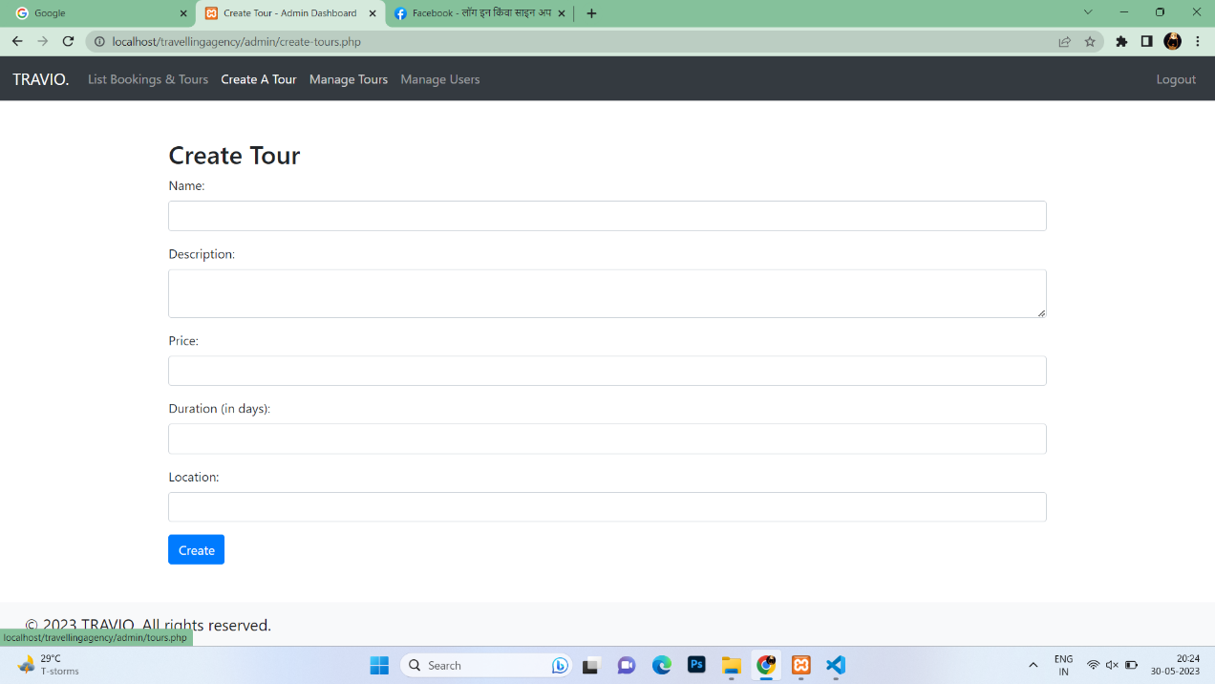

Fig 3.8(2)

**C] Manage Tours**

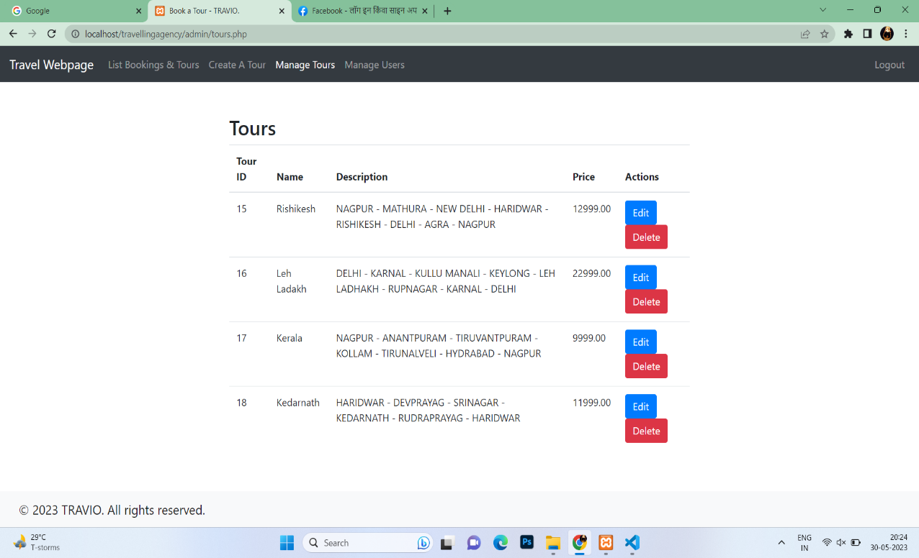

Fig 3.8(3)

**D] Manage Users**

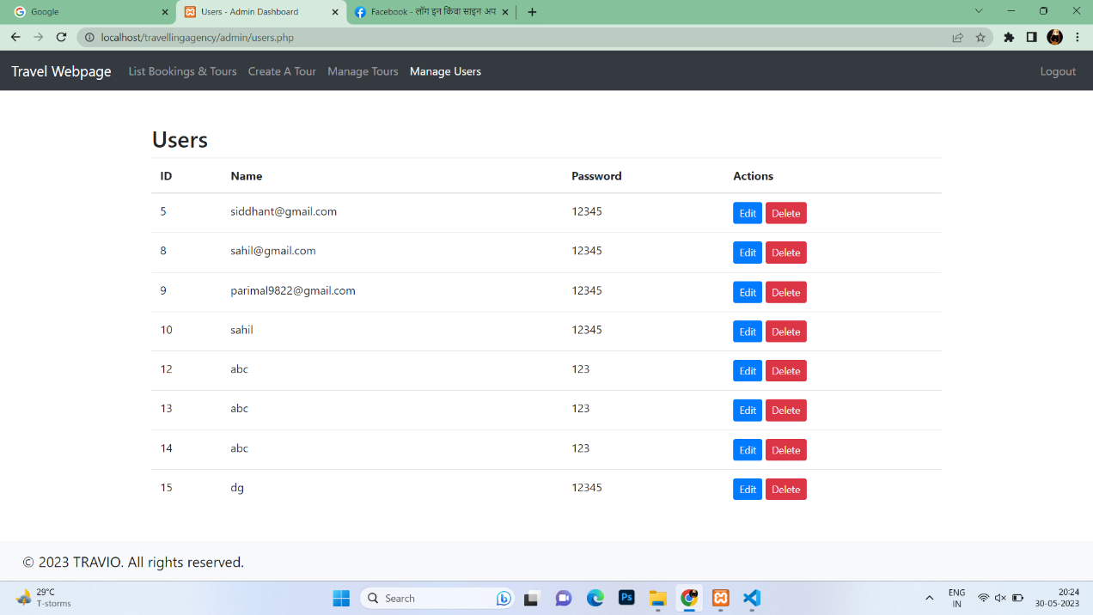

Fig 3.8(4)

**CHAPTER 4**

**ADVANTAGES AND DISADVANTAGES**

# **ADVANTAGES**

* **Tourism brings in money :-** As we already saw, tourism is a huge industry, which means that it has a lot of benefits, including economic and social ones. It provides jobs in hotels, restaurants, and other tourism-related industries.
* **Tourism provides jobs :-** Tourism can provide a significant source of income for local communities. As a result, tourism often generates jobs in various fields like the hospitality and agriculture industries.
* **Stimulates growth of a country :-** Tourism has been a significant area of growth for many countries. It allows the economy to grow and it’s good when it comes to the environment as well. However, there are many ways in which tourism can be encouraged
* **Helps to put nations on the global map –** Tourism is an economic stimulus for the nation. It provides a wide range of benefits, including job creation, exchange of ideas, cultural enrichment, and new technologies. Many countries have started to invest in tourism to make it easier for people to travel abroad on an individual or business level.

# **DISADVANTAGES**

* **Can cause environmental damage :–** There are many disadvantages to tourism, such as the effects on the environment. Tourists will often cause damage during their visit in an attempt to find a photo opportunity. The result is that tourists are often responsible for deforestation and over-exploitation of natural resources.
* **Commercialization :–** Developed countries continue to grow in popularity and can become very crowded. This has led to changes in people’s attitudes and behaviours, including the development of commercialism.
* **Can cause cultures to clash :–** It is a major problem that many countries face due to the nature of tourism. It creates a clash between cultures and may cause the destruction of existing communities.

**CHAPTER 5**

# **CONCLUSION AND FUTURE SCOPE**

**Conclusion**

This web application was successfully created and stored all the travel admin tourism packages booking, creation managing and tour details into the database using this application. The application was tested very well and the errors were properly debugged. Testing also concluded that the performance of the system is satisfactory. All the necessary output is generated. This system thus provides an easy way to automate all the functionalities of consumption. If this application is implemented in few consumption, it will be helpful. Further enhancements can be made to the project, so that the website functions in a very attractive and useful manner than the present one. It is concluded that the application works well and satisfy the needs. The application is tested very well and errors are properly debugged. It also acts as the sharing of files to the valuable resources.

**Future Scope**

Travel and tourism industry is becoming futuristic by inculcating new travel trends in its ecosystem making it more feasible for the public.  Every other thing is done through online mediums, people prefer using contactless methods. Studying tourism can open up a number of lucrative job options, from becoming a travel agent to working in hotel management. Topics like destination marketing, customer service, and event management are frequently covered in tourism courses.

# **REFERENCES**

1. Fikes, R.E., Nilsson, N.J.: STRIPS: A new approach to the application1
   1. of theorem proving to problem solving. Artiﬁcial Intelligence 2(34), 189
   2. 208 (1971)
2. Steﬁk, M.J.: Planning with Constraints. Ph.D. thesis, Stanford, CA, USA (1980), aAI8016868
3. Steﬁk, M.: Planning with constraints (MOLGEN: part 1). Artif. Intell.
   1. 16(2), 111–140 (1981)
4. Kautz, H., Selman, B.: Planning as satisﬁability. In: Proceedings of the
5. 10th European Conference on Artiﬁcial Intelligence. pp. 359–363. ECAI
6. ’92, John Wiley & Sons, Inc., New York, NY, USA (1992)
7. Kautz, H., Selman, B.: Pushing the envelope: Planning, propositional
   1. logic, and stochastic search. In: Proceedings of the Thirteenth Na-
   2. tional Conference on Artiﬁcial Intelligence - Volume 2. pp. 1194–1201.
   3. AAAI’96, AAAI Press (1996)
8. Ernst, M.D., Millstein, T.D., Weld, D.S.: Automatic sat-compilation
   1. of planning problems. In: Proceedings of the Fifteenth International
   2. IJCAI’97, Morgan Kaufmann Publishers Inc., San Francisco, CA, USA
   3. (1997)
9. Blum, A.L., Furst, M.L.: Fast planning through planning graph analysis.
10. Artiﬁcial Intelligence 90(12), 281 – 300 (1997)
11. Giunchiglia, E., Massarotto, A., Sebastiani, R.: Act, and the rest will
    1. follow: Exploiting determinism in planning as satisﬁability. In: Pro-
    2. ceedings of the Fifteenth National/Tenth Conference on Artiﬁcial Intel-
    3. ligence/Innovative Applications of Artiﬁcial Intelligence. pp. 948–953.
    4. AAAI ’98/IAAI ’98, American Association for Artiﬁcial Intelligence,
    5. Menlo Park, CA, USA (1998)
12. Bart´ak, R., Zhou, N.: On modeling planning problems: Experience from
    1. the petrobras challenge. In: Espinoza, F.C., Gelbukh, A.F., Gonz´alez-
    2. Mendoza, M. (eds.) Advances in Soft Computing and Its Applications -
    3. 12th Mexican International Conference on Artiﬁcial Intelligence, MICAI
    4. II. Lecture Notes in Computer Science, vol. 8266, pp. 466–477. Springer
    5. (2013)
13. Basseda, R., Kifer, M., Bonner, A.J.: Planning with transaction logic.
    1. In: Kontchakov, R., Mugnier, M. (eds.) Web Reasoning and Rule Sys-
    2. tems - 8th International Conference, RR 2014, Athens, Greece, Septem-
    3. ber 15-17, 2014. Proceedings. Lecture Notes in Computer Science, vol.
    4. 8741, pp. 29–44. Springer (2014)
14. Basseda, R.: Doctoral consortium extended abstract: Planning with
    1. concurrent transaction logic. In: Calimeri, F., Ianni, G., Truszczynski,
    2. M. (eds.) Logic Programming and Nonmonotonic Reasoning - 13th In-
    3. ternational Conference, LPNMR 2015, Lexington, KY, USA, September
    4. 27-30, 2015. Proceedings. Lecture Notes in Computer Science, vol. 9345,
    5. pp. 545–551. Springer (2015)